FUSION 360 QUIZ



## Inside

MCQ questions divided into categories

Frequently updated

By: Jaiprakash pandey

Introduction

This eBook contains multiple choice questions divided into sections like Part modeling, Assembly and drafting. All the questions have answers at the end of the eBook.

This eBook is frequently updated with new questions, to get the latest copy of your eBook visit [www.thesourcecad.com](http://www.thesourcecad.com/)

Questions? reach me on [admin@thesourcecad.com](mailto:admin@thesourcecad.com)



### Introduction to fusion 360

#### What is the default file format with which Fusion 360 files are saved?

* 1. FSN
  2. F360
  3. **F3D**
  4. FUSION

#### Is it possible to assign custom Keyboard short key to Fusion 360 commands?

* 1. **YES**
  2. No

#### What is the default keyboard short key for extrude command?

* 1. **E**
  2. EX
  3. EXT
  4. X

3 [www.thesourcecad.com](http://www.thesourcecad.com/)

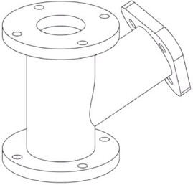

#### Which of the following key combination is used for orbiting drawing?

* 1. CTRL +Middle mouse button
  2. **SHIFT + Middle mouse button**
  3. ALT + Middle mouse button

#### What is the visual style of this part?

* 1. Shaded
  2. Wireframe
  3. Wireframe with hidden edges
  4. **Wireframe with visible edges only**

4 [www.thesourcecad.com](http://www.thesourcecad.com/)

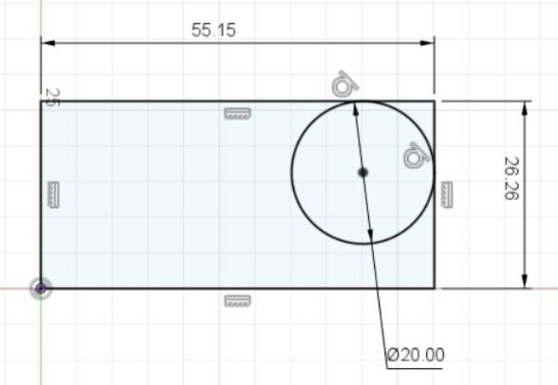

### Making basic sketches

#### What is the color of fully constrained sketches?

* 1. Blue
  2. **Black**
  3. Red
  4. Green

#### Which of the following methods can be used to make the circle as shown in image below?

* 1. Center Diameter circle
  2. 2 point circle
  3. 3 point circle
  4. **2 Tangent circle**

5 [www.thesourcecad.com](http://www.thesourcecad.com/)

#### The “Chain selection” checkbox on the offset command panel will do the following



* 1. Will select all tangentially connected curves
  2. **Will select all end to end connected curves**
  3. Will let you select only selected curve

#### State true or false: To apply fillet you can select adjacent edges as well as vertex of intersecting lines.

* 1. **True**
  2. False

#### Which of the following is the command alias of Mirror command?

* 1. M
  2. R
  3. S
  4. **Mirror command has no alias by default**

6 [www.thesourcecad.com](http://www.thesourcecad.com/)

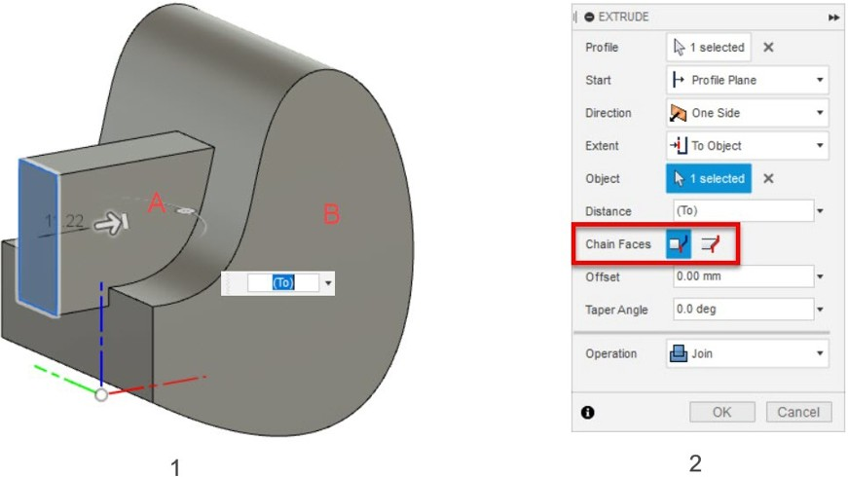

### Basic 3D modelling

#### You need a sketch to make which of the following primitives?

* 1. Box
  2. Torus
  3. Coil
  4. **Pipe**

#### In the image below, the rectangle on the left is extruded and in the extent option “to object” is selected as marked in the red box of extrude palette. Then flat plane of object B is selected as the reference object up to which the rectangle is to be extruded. The final shape of the extruded rectangle is as shown in image below. Which of the following options in “chain faces” will make this kind of extruded rectangle which extends up to the curved part of object B as well?

7 [www.thesourcecad.com](http://www.thesourcecad.com/)

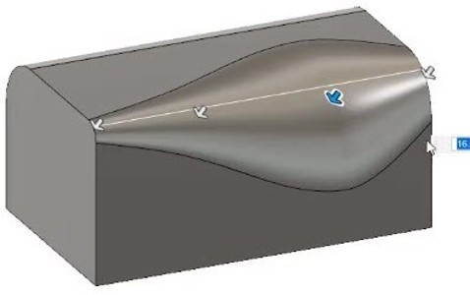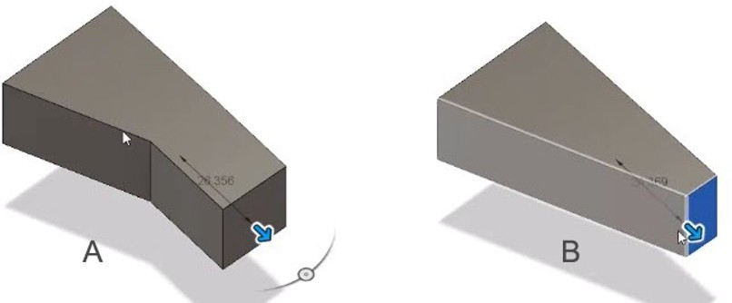

1. Extend Faces
2. **Chain Faces**

#### What is the name of fillet applied on the edge of this cuboid?

* 1. Constant Length
  2. Chord length
  3. **Variable radius**

#### Which of the following commands will extrude the tapered solid along its tapered path as shown in figure B.

8 [www.thesourcecad.com](http://www.thesourcecad.com/)

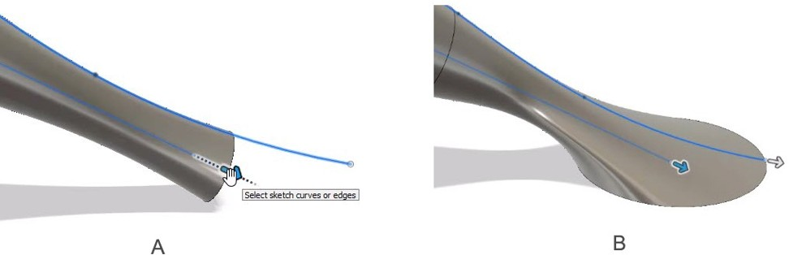

1. Extrude
2. **Presspull**

#### Which of the following option of the Extent menu of Sweep palette should be selected to get the sweep as shown in figure B.

* 1. Perpendicular to the path
  2. **Full extents**

9 [www.thesourcecad.com](http://www.thesourcecad.com/)

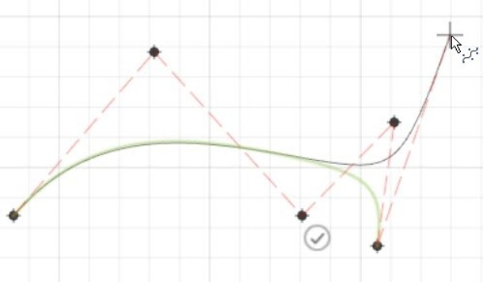

### Sketch Features

1. In which of the following polygons the reference line connects the center of reference circle to the vertex of polygon.
   1. **Inscribed**
   2. Circumscribed
2. What is the type of spline in the following image?
   1. Fit point spline
   2. **Control point spline**
3. What is the rho value for an ellipse?
   1. **<0.5**
   2. >0.5

C. =0.5

10 [www.thesourcecad.com](http://www.thesourcecad.com/)



1. State true or false: We can extrude text directly in Fusion 360 without converting it into line geometry.
   1. **True**
   2. False
2. To specify the distance between first and last object along horizontal or vertical direction of a rectangular array which of the following “distance type” options you will choose from “Rectangular pattern” palette?
   1. Spacing
   2. **Extent**

11 [www.thesourcecad.com](http://www.thesourcecad.com/)

Construction and Measurement

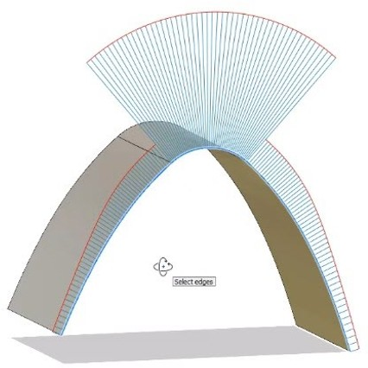

1. Can we make a plane at the angle bisector of two intersecting planes using “Midplane” option of construction planes?
   1. **Yes**
   2. No
2. Is it possible to measure different dimensions in the drawing using different units?
   1. **Yes**
   2. No
3. What is the surface continuity type of the following surfaces?
   1. G0
   2. **G1**
   3. G2
   4. G3

## 12

[www.thesourcecad.com](http://www.thesourcecad.com/)



1. Fill the blank: The curvature comb lines are proportional

to the radius of surface.

* 1. Directly
  2. **Inversely**

1. State true or false: Zebra analysis can’t be used to check deformity in the surfaces.
   1. True
   2. **False**

13 [www.thesourcecad.com](http://www.thesourcecad.com/)

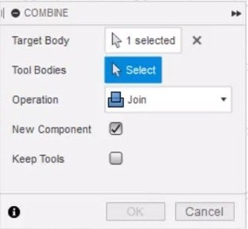

Modelling Features

1. What will the “Keep Tools” feature do when checked on Combine panel as shown in image here?
   1. Will not perform combine operation
   2. Will perform combine operation and will remove remaining selected bodies
   3. Will perform combine operation and also keep remaining selected bodies
   4. **Will perform combine operation and also keep original selected bodies**
2. State true or false: Can we make Web and Rib features with open sketches that don’t touch the boundary of the bodies?
   1. **Yes**
   2. No

14 [www.thesourcecad.com](http://www.thesourcecad.com/)



1. In the M20x1.5 what does 1.5 stand for?
   1. Hole diameter
   2. **Pitch of thread**
   3. Hole depth
   4. Drill tap angle
2. **What is the disadvantage of a modelled thread over cosmetic thread?**
   1. It’s time consuming to make in Fusion 360
   2. **It makes part complex and hence effects performance**
   3. It does not look good on part
3. State true or false: We can scale 3D solid body along different axes using different scale factors.
   1. **True**
   2. False

15 [www.thesourcecad.com](http://www.thesourcecad.com/)



Advance Modelling tools

1. We can project which of the entity of an object on a plane using Project tool?
   1. Edges
   2. Reference planes
   3. Complete bodies
   4. **All the above**
2. Which of the following tool can be used to extract edges of a body right where they are?
   1. Project
   2. Intersect
   3. **Include 3D geometry**
   4. Project to surface
3. Which of the following is false?
   1. Appearance and physical properties both change the visual appearance of object
   2. **You can’t have different appearance and physical properties for the same object or body**
   3. We can apply materials like wood for appearance as well as physical proprieties
   4. Appearance changes only the way an object looks whereas physical properties changes properties like weight and density of object

16 [www.thesourcecad.com](http://www.thesourcecad.com/)



1. State true or false: It is important to deactivate design history for working with parts containing meshes.
   1. **True**
   2. False
2. Which of the following is not a part library for Fusion 360?
   1. **Design center**
   2. Mc Master-carr component
   3. Manufacturer partF5

17 [www.thesourcecad.com](http://www.thesourcecad.com/)



Working with Assemblies in Fusion 360

1. Which of the following is not true for linked component?
   1. You can only use fusion files (f3d files) as linked component
   2. Changes made to actual component updates it in the assembly as well
   3. **Mates can’t be applied to a linked component**
2. Which of the following is not correct for Grounded component?
   1. It becomes fixed at its place
   2. **You can’t ground more than one component**
   3. Joints won’t drive the component anymore
3. Which of the following joint is a combination of slider and revolute joint?
   1. **Cylindrical**
   2. Pin slot
   3. Planar
   4. Ball
4. Which of the following options will create a reference point for assembly joints?
   1. Rigid Group
   2. **Joint origin**
   3. Drive Joints
   4. Motion Link

18 [www.thesourcecad.com](http://www.thesourcecad.com/)



1. Why it’s not recommended to add contact sets in larger assemblies?
   1. The amount of data to be processed will be very high for the software to handle
   2. The assembly will start to lag
   3. Performance issues will arise
   4. **All the above**

19 [www.thesourcecad.com](http://www.thesourcecad.com/)

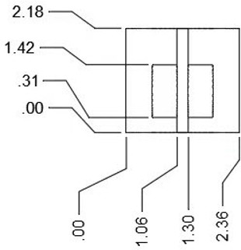

All about drawing in Fusion 360

1. We can make drawings in which of the following angles of projection? (two answers are correct)
   1. **First angle**
   2. Second angle
   3. **Third angle**
   4. Fourth angle
2. The projected views move in aligned direction with respect to the parent view, to break this alignment which key can be used?
   1. CTRL
   2. ALT
   3. **SHIFT**
   4. TAB
3. What is the dimension type applied on the following drawing?

20 [www.thesourcecad.com](http://www.thesourcecad.com/)



1. Baseline
2. Chain
3. **Ordinate**
4. Linear
5. State true or false: When a component is modified its drawing also changes automatically in the Drawing workspace.
   1. **True**
   2. False
6. **Is it possible to add exploded view of entire assembly as well as separate component drawings in a single drawing containing multiple sheets?**
   1. **Yes**
   2. No

21 [www.thesourcecad.com](http://www.thesourcecad.com/)

22

[www.thesourcecad.com](http://www.thesourcecad.com/)

Answer Key

# Introduction to fusion 360



Question 1 - C Question 2 - A Question 3 - A Question 4 - B Question 5 - D

# Making basic sketches

Question 1 - B Question 2 - D Question 3 - B Question 4 - A Question 5 - D

# Basic 3D modelling

Question 1 - D Question 2 - B Question 3 - C Question 4 - B Question 5 - B

23

[www.thesourcecad.com](http://www.thesourcecad.com/)

Answer Key

# Sketch Features



Question 1 - A Question 2 - B Question 3 - A Question 4 - A Question 5 - B

# Construction and Measurement

Question 1 - A Question 2 - A Question 3 - B Question 4 - B Question 5 - B

# Modelling Features

Question 1 - D Question 2 - A Question 3 - B Question 4 - B Question 5 - A

24

[www.thesourcecad.com](http://www.thesourcecad.com/)

Answer Key

# Advance Modelling tools



Question 1 - D Question 2 - C Question 3 - B Question 4 - A Question 5 - A

# Working with Assemblies in Fusion 360

Question 1 - C Question 2 - B Question 3 - A Question 4 - B Question 5 - D

# All about drawing in Fusion 360

Question 1 - A , C Question 2 - C Question 3 - C Question 4 - A Question 5 - A

[www.thesourcecad.com](http://www.thesourcecad.com/)

This eBook was made possible by the efforts of Jaiprakash Pandey and Kalpana Pandey

To learn more about Fusion 360 visit SourceCAD on [www.thesourcecad.com](http://www.thesourcecad.com/)

Questions? Let us know on [admin@thesourcecad.com](mailto:admin@thesourcecad.com)